Improving Women's Skills And Economy In Kecupak II Village, Pakpak Bharat With Pandan Handicrafts Training

Lister Berutu¹, Nita Savitri², Nurbani³
^{1,2,3}Universitas Sumatera Utara, Medan, North Sumatera, Indonesia

Article Info |  | ABSTRACT
Keywords:  Women Empowerment,  Pandan Handicrafts,  Economy,  Kecupak II Village. |  | This study aims to explore the empowerment of pandan craftsmen as a means of improving the economic welfare of women in Kecupak II Village, PGGS District, Pakpak Bharat Regency. The pandan handicrafts in this village have significant potential for development, but limited access to markets and skill training has resulted in suboptimal income for artisans, especially women. Through a community empowerment approach, this research focuses on skill development, product quality enhancement, and broader market access. The research method used is a qualitative approach with data collection techniques including interviews, observations, and focus group discussions (FGD) with artisans, community leaders, and other relevant stakeholders. The findings indicate that training in skills, strengthening business management, and improved market access can increase product quality and competitiveness of pandan handicrafts in local and regional markets. Furthermore, this empowerment initiative has opened up economic opportunities for women, increased household incomes, and strengthened the role of women in the village economy. As a recommendation, further support from the government and related institutions is needed to provide advanced training, broader marketing access, and business capital assistance to sustain and advance the pandan handicraft industry. In this way, the empowerment of pandan craftsmen in Kecupak II Village is expected to become a model for community-based economic empowerment that empowers women and enhances the overall well-being of the village community.
This is an open access article under theCC BY-NClicense |  | Corresponding Author:  Lister Berutu  Universitas Sumatera Utara, Medan, North Sumatera, Indonesia  listerberutu60@gmail.com

INTRODUCTION
Kecupak II Village is located in Pakpak Bharat Regency, North Sumatra, approximately 180 km from Medan City as the capital of North Sumatra Province and 4 (four) kilometers from Salak City as the capital of the district. The population of the village is 1,875 people and 475 heads of families, spread across seven hamlets. The main occupation of the majority of the population is farming. (85%), the rest as ASN and small traders. Agricultural products include: rice, coffee, frankincense and various types of secondary crops. Various types of crafts carried out by both men and women are only intended for their own needs, even though they can be developed for additional income (Kecupak II Village Head Office 2024).
Materials used for crafts include; various types of pandan, rattan, bamboo and wood. These ingredients are all available in the forests around the village and some are cultivated, such as pandan. Special crafts made from pandan or in local language called Bangkuang, have only been carried out by women from time to time until now. In the past, every woman had to be good at weaving in order to be considered mature and ready to get married, but as times change, this obligation no longer applies so young people rarely learn it. However, until now there are still a handful of women who are skilled at weaving because this skill is actually passed down from generation to generation. In other words, it becomes traditional wisdom or local wisdom of the local community.
Women usually weave in between their main jobs as farmers. Usually done at night before going to bed, or during rainy days or during leisure farming periods. There are several types of products produced from pandan crafts that are usually used for daily life and for traditional equipment, including (1) various types of traditional mats, (2) large chopsticks called Kembal; (3) small chopsticks called Silampis; and (4) men's and women's bags called Ucang. However, it is possible to also develop them for daily needs, both as knickknacks and other accessories.
These types of products are always and continuously needed when villagers carry out traditional ceremonies, both life cycle ceremonies and other ceremonies, such as ceremonies. birth of a child, marriage ceremony, death ceremony, ceremony of entering a new house and other ceremonies.
So far, according to the Head of Kecupak II Village, people have been forced to buy at the market or from other villages, even from other areas such as Aceh Singkil Regency, Aceh Province, because the human resources in the village are not able to meet the needs of the community, even though the natural resources in the village area are very abundant and easy to obtain, both from cultivation and growing wild in the forests around the village.
As explained earlier, the craft culture is actually very attached to the Pakpak community in general and the Kecupak II village community in particular, but it is underdeveloped because the craftsmen are not sure they can develop economically from the results of the crafts alone. In addition, the government also pays less attention to the wealth of local wisdom so that the development of the craft is stagnant and even marginalized, even though economically it can actually increase the income of the community, especially women, from pandan crafts. The following are attached several photos related to the subject of community service in Kecupak II village, Pergetteng-getteng Sengkut District, Pakpak Bharat Regency.
In an effort to develop local wisdom, especially improving women's skills and economic development, we from the USU Community Service and Development (LPPM) team are carrying out community service. This service is entitled: Empowering Pandan Craftsmen to improve women's economy in Kecupak II Village, PGGS District, Pakpak Bharat Regency. This topic or activity is interesting for several reasons. First, the number of women interested in weaving crafts is very rare, whereas in the past it was an obligation for every Pakpak woman to be considered mature and ready to marry. Second, the results of crafts made from pandan leaves are still needed by the wider community for the purposes of traditional ceremony equipment. As a result, for these needs, residents are forced to buy from outside the village, even from outside the district, especially from Aceh Singkil. Third, from an economic perspective, the results of these craft products are quite promising for increasing family income, especially for women. Fourth, the natural resources are also very abundant because the basic materials are quite abundant in the forest and are easy to cultivate because they grow easily and do not require intensive care. With these four reasons, this service is considered important and useful.

METHOD
Based on the problems and solutions explained previously, the methods and techniques for implementing community service are: (1). Socialization of the importance of preserving and developing local wisdom, especially pandan crafts for participants, both as a cultural identity and to increase the creativity of local communities. The method used is a joint study (FGD) with parties considered strategic. Thus, the products produced can increase family income, especially for women because the market is traditionally always there because it is needed for the completeness of various traditional ceremonies. If developed, it is not closed to other needs, such as accessories, such as hats, wallets, cellphone holders and others. The method begins with a short lecture from the team followed by a discussion with the socialization participants. The implementation of this activity was carried out at the Kecupak II Church Hall. Participants in this activity were village heads, village officials and community leaders. The number of participants is estimated to be 40 people. This activity was carried out by means of lectures and discussions about the diversity of local wisdom in general and Pakpak local wisdom in particular. The lecture will be delivered by the Community Service Team; (2) Establishment of a standard and sustainable Pandan Craftsmen Group in Kecupak II Village, Pakpak Bharat Regency; and (3) Training in making woven pandanus for traditional rituals and other needs.

RESULT
Implementation of Community Service
This community service activity is funded by the Community Service and Development Institute of the University of North Sumatra. In accordance with the amount of funds we received, the team can only facilitate training for 4 days with details of 1 (one) trainer, 6 (six) training participants and 1 (one) supervisor from the village apparatus. They are expected to be the seeds of growing interest in young women to return to actively developing weaving crafts in the village in particular and in Pakpak Bharat Regency in general.
This training activity was carried out by the University of North Sumatra in collaboration with the Kecupak II Village government, Pakpak Bharat Regency. To further increase the echo of this community service activity, we and the village government also invited other parties as participants of the focus group deliberation (FGD), including from the Tourism and Culture Office, Sub-district Head, DPRD, community leaders and the Head of Sulang Silima Marga Manik. They were given the opportunity to provide opinions and suggestions and input for the sustainability of future community service activities. This court event began with holding a joint discussion (FGD) and after the joint discussion was continued with training guided by 1 (one) trainer for 4 (four) consecutive days.
In the discussion event (FGD) began with a general presentation from Drs Lister Berutu MA as the head of the community service team continued by Dra. Nita Savitri, M.Si as a representative of the team members. As the team leader, Lister Berutu first introduced all team members including the students involved. Continued with a presentation on the main duties of a university lecturer, namely the Tri Dharma of Higher Education, one of which is community service. Then continued with the reasons for choosing to develop pandan weaving crafts in Kecupak II village. The reason is that pandan crafts have great potential to be developed because the human and natural resources are very supportive so that they can increase family income. After the leader was finished, a short presentation was continued by Nita Savitri who said, we women must be independent, at least to meet personal needs such as make-up, soap, and other needs without having to depend on our husbands. In this activity
The community service team also invited women and mothers in Kecupak II village to start actively developing pandan crafts. The potential of pandan craftsmen is very high, so they can create pandan weaving into items that sell well in the general market, such as handbags, laptop bags, and hats. In addition, the needs for traditional ceremonies in the village and district can be met and there is no need to buy from outside.
After the presentation from the team, it was continued with a discussion and giving opinions randomly and freely to all participants. In essence, all participants responded positively, both from village officials, sub-district heads, tourism offices and members of the DPRD who were present. One very important agreement was the formation of a standard management of the craftsmen team named: NGKASAH MEMBAYU which means Diligent weaving. The management consists of: Chairperson: Sekukat br padang, Secretary: Kasidah br Berutu and Treasurer: Resti br Manik. The village secretary then makes a Decree and in the SK it will be equipped with sections.
The establishment of the Ngkasak Membayu studio received support from the representative of the Pakpak Bharat DPRD member Sabar Manik. He was very determined because Mrs. Nita Savitri as a Minang tribe loves Pakpak culture. He appealed to the management to always be active and motivated in activities. As a member of the DPRD, he promised to fight for a budget that could be allocated to the Kasak Membayu studio. The same thing was said by the Head of Sulang Silima Marga Manik Wilson Manik, he greatly appreciated USU because it was still trying to preserve Pakpak culture, especially in pandan weaving. In Pakpak customs, pandan plays a very important role. He said that for one traditional event, Pakpak people spend almost 2 million rupiah to buy pandan crafts such as various types of mats and chopsticks (haliu). The sub-district head and the tourism and culture office also promised to help develop the newly formed studio, both in terms of funding and marketing. The FGD activity ended with an inauguration and then a meal together with all participants and after lunch it was continued with training guided by a predetermined trainer.
During the inauguration, in his welcoming speech, the village secretary said that this training is very useful because in addition to increasing skills, it can also be a new source of income for residents. We hope that activities like this can continue," he said. One of the participants, Sepakat Padang as the elected chairman, expressed his pleasure in participating in this training. "I am very happy to be able to participate in this training. In addition to gaining new knowledge, I can also gather and exchange experiences with trainers sent by the USU TEAM," said Mrs. Sepakat.
Structured training is carried out for four days guided by skilled trainers and after that all participants continue at their respective homes. In the training session, participants are taught basic to advanced techniques in weaving pandan into various products such as mats and chopsticks (haliu) needed in traditional ceremonies. In the future, it will be continued with other products that have a wider market. During the training, the team participated in monitoring the process for 4 days and was routinely supervised by the village secretary.
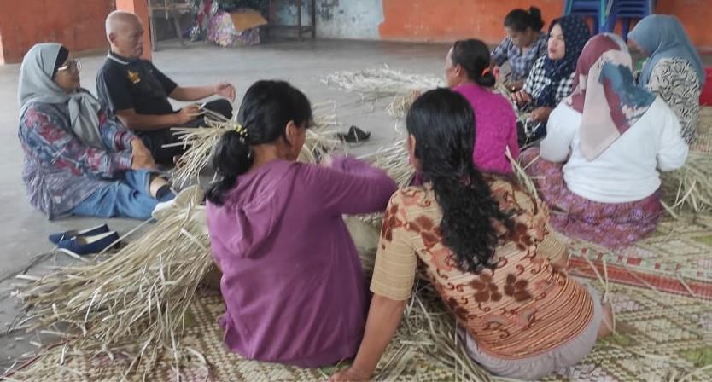

Figure 1. Service Team Witnesses Training
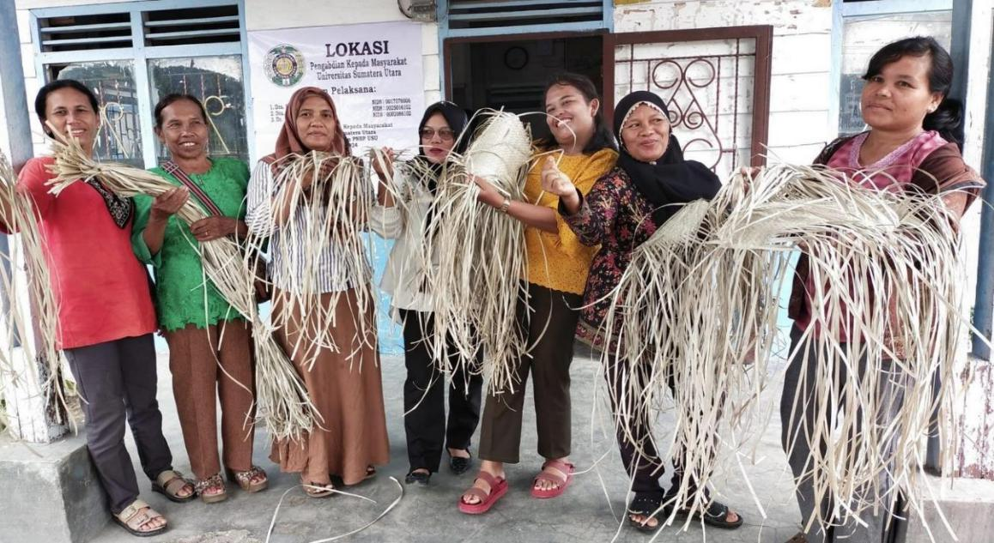

Figure 2. Training Participants And Trainers

Results and Outcomes of Service
Community service has been carried out well and according to plan in collaboration with the village government of Kecupak II, Pergetteng-getteng Sengkut District, Pakpak Bharat Regency with the following results: (1) Establishment of Institutions. One very important agreement is the establishment of a standard management of the craftsmen team named: NGKASAH MEMBAYU which means Diligent in weaving. The management consists of: Chairperson: Sepakat br Padang, Secretary: Kasidah br Berutu and Treasurer: Resti br Manik. The village secretary then makes a Decree and the Decree is equipped with sections. (2). Structured training is carried out for four days guided by skilled trainers and after that all participants continue at their respective homes. In the training session, participants are taught basic to advanced techniques in weaving pandan into various products such as mats and chopsticks (haliu) which are needed in traditional ceremonies. In the future, it will be continued with other products that have a wider market. During the training, the team participated in monitoring the process for 4 days and was routinely supervised by the village secretary. The service team carried out this activity in the former GKPPD church building (Pakpak Dairi Christian Church) which is located right in front of the Kecupak II Village Head Office. (3). From the process that has been carried out, the service team has achieved the following outputs: publishing online news, YouTube and compiling articles that have been published in journals with ISBNs.

CONCLUSION
Weaving is one type of craft that is well known to both Pakpak men and women in general, because it is a form of traditional wisdom or local wisdom that has been known for generations. The basic materials for weaving come from biota in the surrounding environment, both from wild plants in the forest and those that have been cultivated around yards, gardens and other places. The materials used include: Bamboo, Wood, Bark, and various types of pandan leaves. Specifically, pandan crafts are a form of craft that is done by women and one type of pandan is known as Bangkuang which is usually planted around the yard or in the fields. Crafts made from pandan (Bangkuang) still exist today because they are needed for Weaving is one type of craft that is well known to both Pakpak men and women in general, because it is a form of traditional wisdom or local wisdom that has been known for generations. The basic materials for weaving come from biota in the surrounding environment, both from wild plants in the forest and those that have been cultivated around yards, gardens and other places. The materials used include: Bamboo, Wood, Bark, and various types of pandan leaves. Specifically, pandan crafts are a form of craft that is done by women and one type of pandan is known as Bangkuang which is usually planted around the yard or in the fields. Crafts made from pandan (Bangkuang) still exist today because they are needed for wider. As a result, it is able to increase and improve the income of the community, especially village women. For this reason, the Pakpak Bharat regional government should be able to facilitate the preservation of various local arts in the region, including the development of pandan crafts carried out by women.

REFERENCES
Afrizal (2010), Identification of Customary Law Communities and Local Wisdom, Paper at the Environmental Workshop, Jakarta, Unpublished.
Agustono, Budi, (2010), Reconstruction of Ethnic Identity: Socio-Political History of the Pakpak People in North Sumatra 1958-2002, Doctoral Dissertation in Humanities, Faculty of Cultural Sciences UGM, Yogyakarta, not published.
Ahimsa Putra, Heddy (2007), Introduction" in Simintarsih (author), Traditional Wisdom Rural Communities in Maintaining the Natural Environment of Gunung Kidul Regency, Yogyakarta, Jakarta, Ministry of Culture and Tourism of the Republic of Indonesia.
Berutu, Lister, 2010, The Wisdom of the Pakpak Indigenous Community and the Role of Sulang Silima in Forest Management and Conservation, Paper at a Workshop facilitated by The International Salidarity for Justice World Foundation (SABDA) at the Beristra Sidikalang Hotel on 21-23 June 2010.
Berutu, Lister, 2010, Local Wisdom of Pakpak Society and its Significance for Nature Conservation Efforts, paper presented at a Workshop facilitated by Pusaka Indonesia at Hotel Sibayak Berastagi March 2010.
Berutu, Lister (1996), New Year Ceremonies and Their Meaning for Environmental Conservation, in Warta ATL, edition III, pp. 21-28.
Emmerson, Robert M., Rachel I. Fretz & Linda L. Shaw (1995) Writing Ethnographic Fieldnotes.Chicago: The University of Chicago Press. Pg 1-38
Fetterman, David M. (1989) Ethnography Step by Step. Newbury Park, London, New Delhi: Sage Publications. pp. 11-72l. APPENDICES
Farsyah, Muda (2007), Traditional Wisdom of the Sibonggar Julu Village Community Regarding the Maintenance of the Natural Environment in Madina Regency, North Sumatra, Jakarta, Department of Culture and Tourism.

